Link dan QR Code Course Survey Kursus Sem 1 2022/2023

Tahun 1
EAA110/2 | https://forms.office.com/r/A9gjuKj43M | 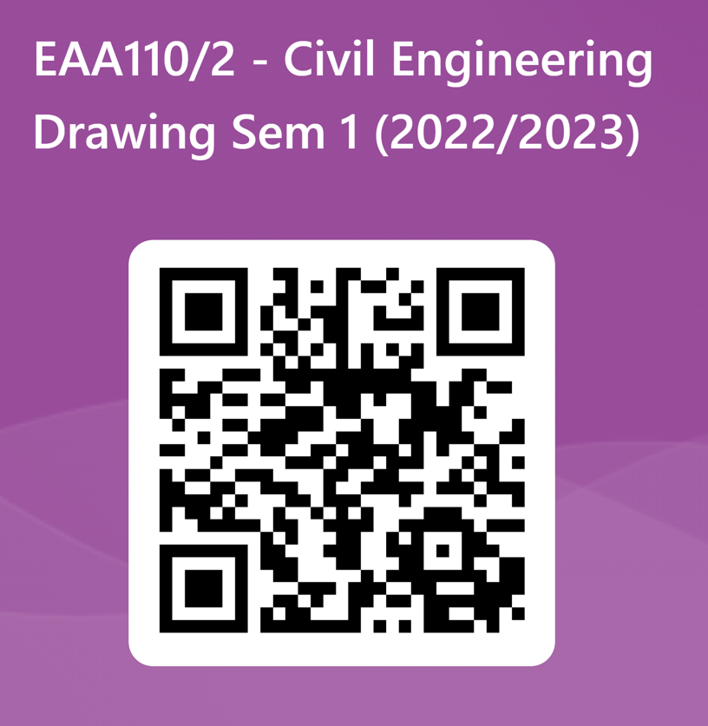
EAA111/2 | https://forms.office.com/r/Ai19mewZ84 | 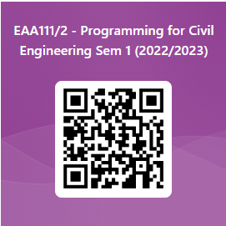
EAG141/2 | https://forms.office.com/r/zyMrnJwAZy | 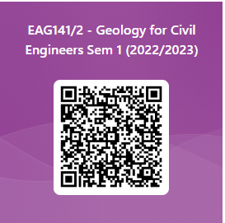
EAS151/3 | https://forms.office.com/r/ueMgzYN2Cf | 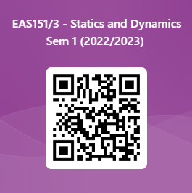
EAS153/3 | https://forms.office.com/r/bDMRjPmUPc | 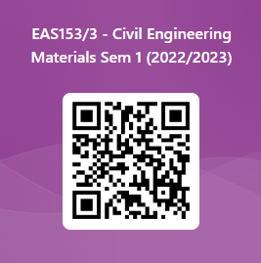

Tahun 2
EAA204/2 | https://forms.office.com/r/7GXZ57d6d6 | 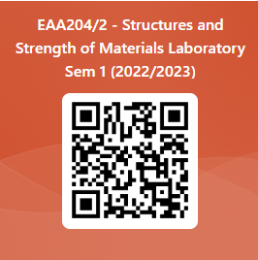
EAA211/2 | https://forms.office.com/r/G3iJLeM2MR | 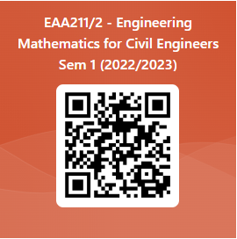
EAH221/3 | https://forms.office.com/r/SBq1P5G1iz | 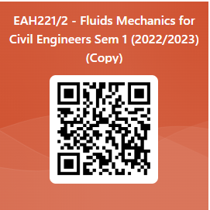
EAG245/3 | https://forms.office.com/r/yM4jAeMqhB | 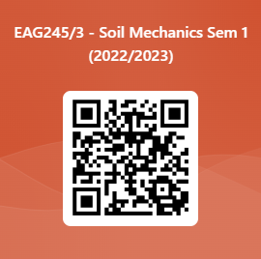
EAS253/3 | https://forms.office.com/r/A4MNCzF1Yn | 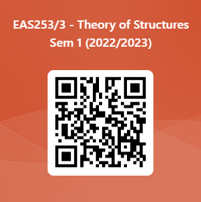
EAA273/2 | https://forms.office.com/r/ayZCEbk6CF | 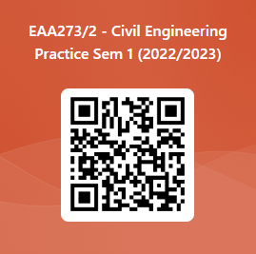

Tahun 3
EAA305/2 | https://forms.office.com/r/9pMKpkWxXX | 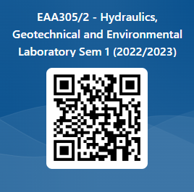
EAP315/3 | https://forms.office.com/r/0sje7ns8Hf | 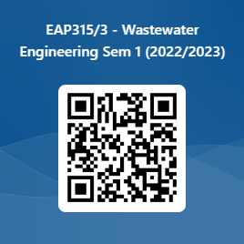
EAL337/3 | https://forms.office.com/r/6USHaVvps0 | 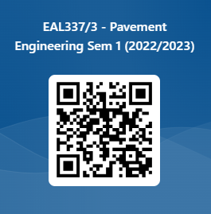
EAG345/3 | https://forms.office.com/r/Qzj4UBx66n | 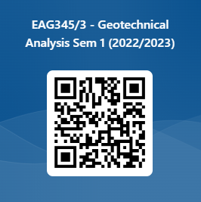
EAS353/3 | https://forms.office.com/r/Rq7kuJX01y | 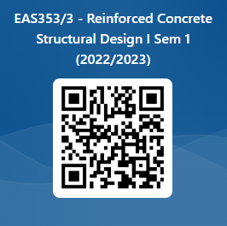
EUP222/3 | https://forms.office.com/r/H5VaVCszpJ | 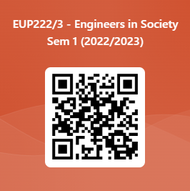

Tahun 4
EAP415/2 | https://forms.office.com/r/6LPPVVxBQP | 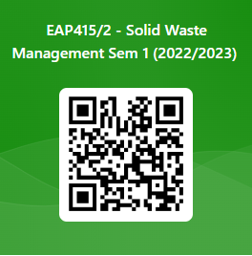
EAH417/2 | https://forms.office.com/r/bEnzaj2uvE | 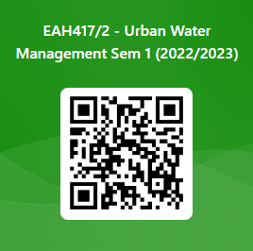
EAS457/2 | https://forms.office.com/r/ggCrHfRbrr | 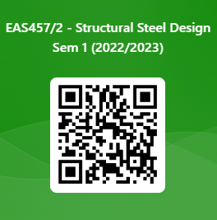
EAS451/2 | https://forms.office.com/r/7UFJLDET10 | 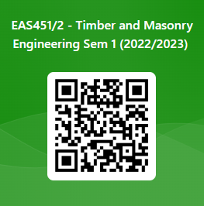
EAA483/2 | https://forms.office.com/r/3G6x8tGsHV | 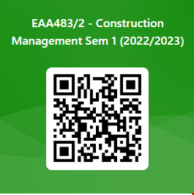
EAA485/2 | https://forms.office.com/r/1330XRnM8a | 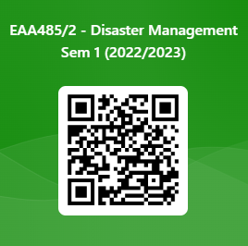
EAG444/2 | https://forms.office.com/r/pWBY6TtzJk | 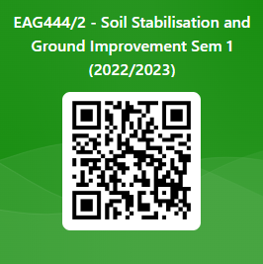
EAL431/2 | https://forms.office.com/r/uTiR9VSN3G | 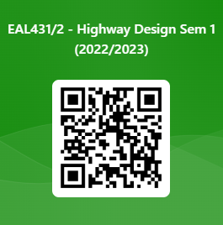
EAA495/4 | https://forms.office.com/r/SnT1F283VA | 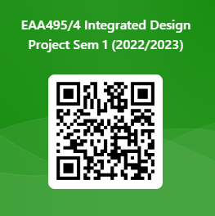
EAA492/6 | https://forms.office.com/r/y1q8zFQSaD | 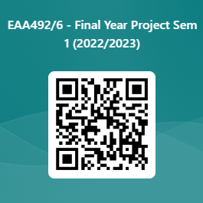
EAA371/5 | https://forms.office.com/r/zz6anfzK68 | 